Apache Spark Assignment [21-12-2023]

By Karthikeyan K R

Installation of Apache Spark:

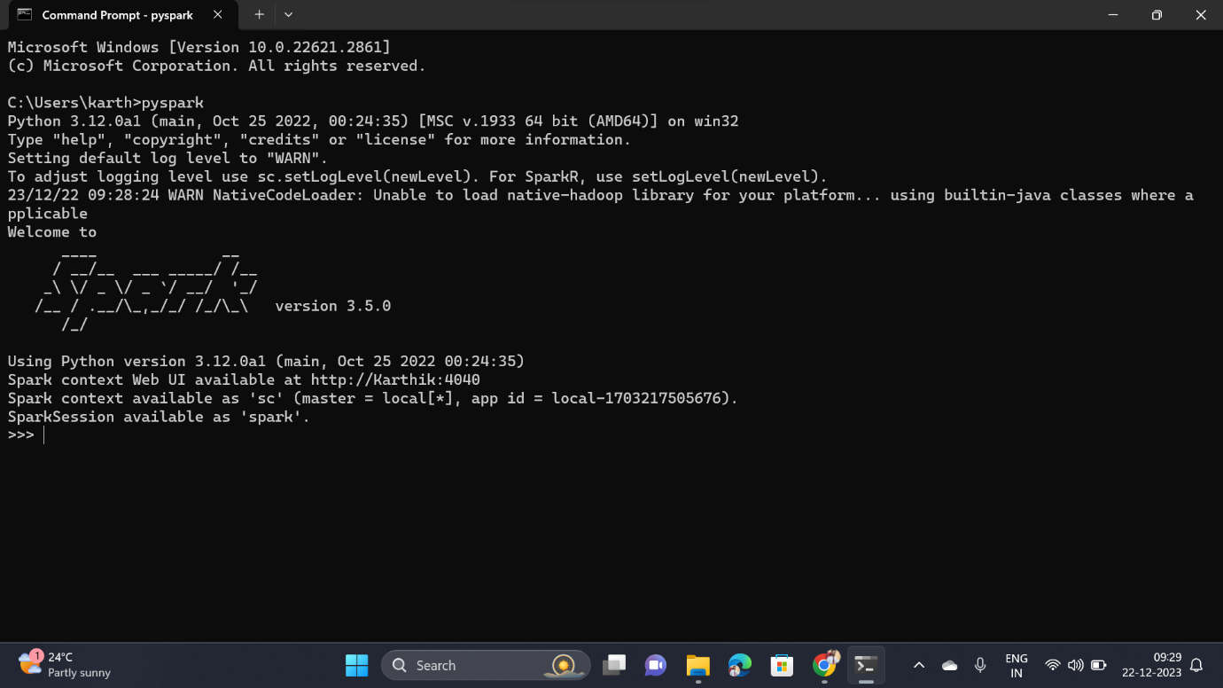

Apache Spaek Web UI:

